Assignment : 1

Module 1:

Understanding of hardware and its components

Section 1: multiple choices.

1. Which of the following is NOT a component of the CPU?

1. ALU , 2. RAM , 3. CU , 4. 1 and 3 both

Ans : 2. RAM

1. What is the function of the RAM in a computer ?

Ans : To store Data.

1. Which of the following is a primary storage device ?

1. HDD , 2. SSD , 3. SD card , 4. 1 and 2 both

Ans : 4. 1 and 2 both.

1. what is the purpose of GPU ?

Ans : Accelerate the rendering of images and videos.

Section 2 : True or False.

1. The motherboard is the main circuit board of a computer where other components are attached.

Ans : TRUE

1. A UPS (Uninterruptible Power Supply) is a hardware device that provides emergency power to a load when the input power source fails.

Ans : TRUE

1. An expansion card is a circuit board that enhances the functionality of a component.

Ans : True

Section 3 : Short Answers.

1. Explain the difference between HDD & SSD.

Ans :

* HDD stands for Hard disk drive.
* It’s read latency time is high.
* Hard disk’s random access time is 5-10 ms.
* It’s large and heavy compared to SSD.
* Till now HDD are available up to 4TB.
* SSD stands for solid-state drive.
* It’s read latency time is lower then HDD.
* It’s random access time is 0.11 ms.
* Its small and light weighted.
* Till now SDD are available up to 2 TB.

1. Describe the function of BIOS in a computer system.

Ans : In a computer system , the BIOS is built into motherboard and acts as the bridge between the hardware and the operating system.

BIOS stands for basic input output system.

1. List and briefly explain three input devices commonly used for computer.

Ans :

* Keyboard : keyboard is most common and very popular input device which helps in inputting data to the computer.
* Mouse : mouse helps to control a pointer in the screen helps user to select or drag.
* Scanner : scanner is an input device which work like a photocopy machine that converts physical document into digital form.

Section 4 : Practical applications.

1. Identify and label the following components on a diagram of motherboard:

* CPU
* RAM slots
* SATA connectors
* PCI-E slots
* CPU

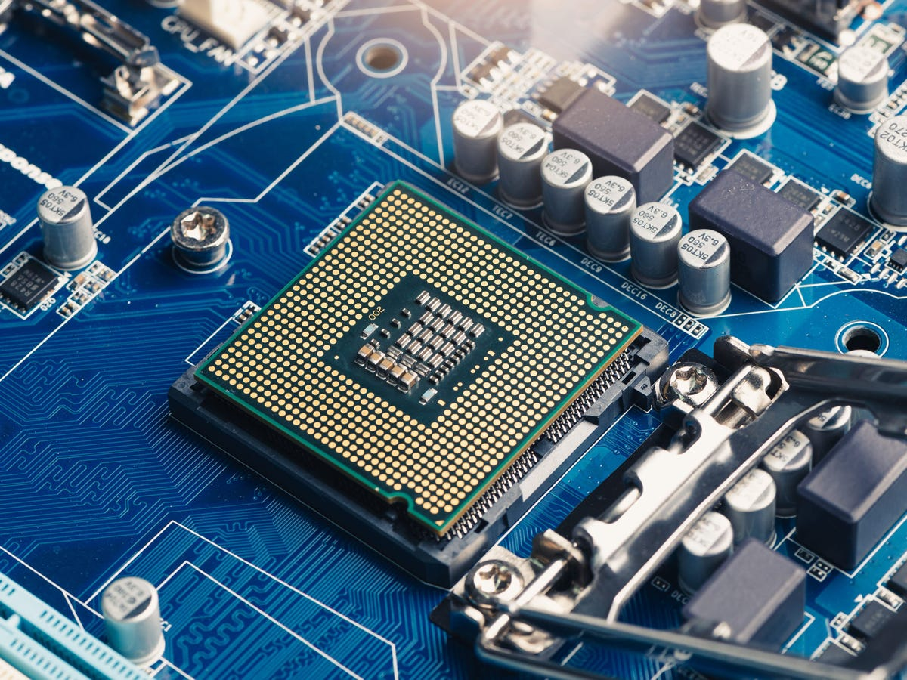

* RAM SLOTS.

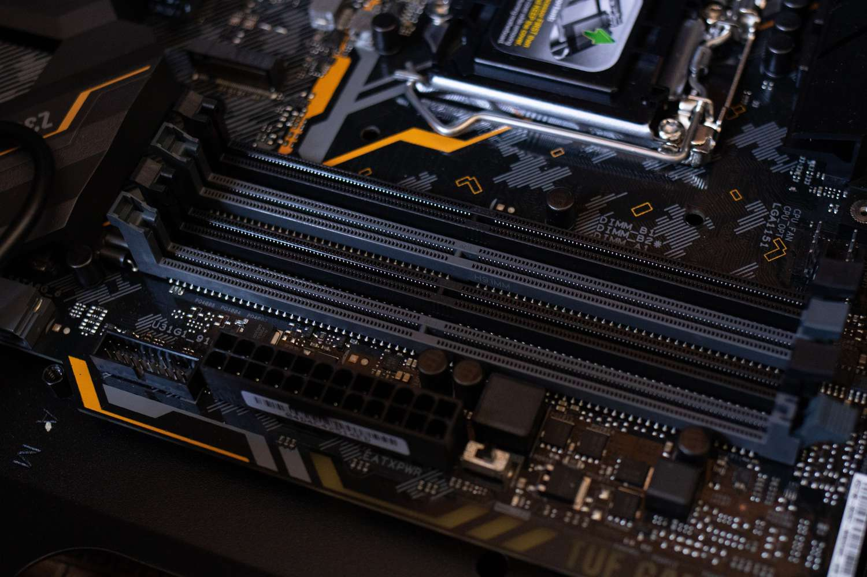

* SATA connectors.

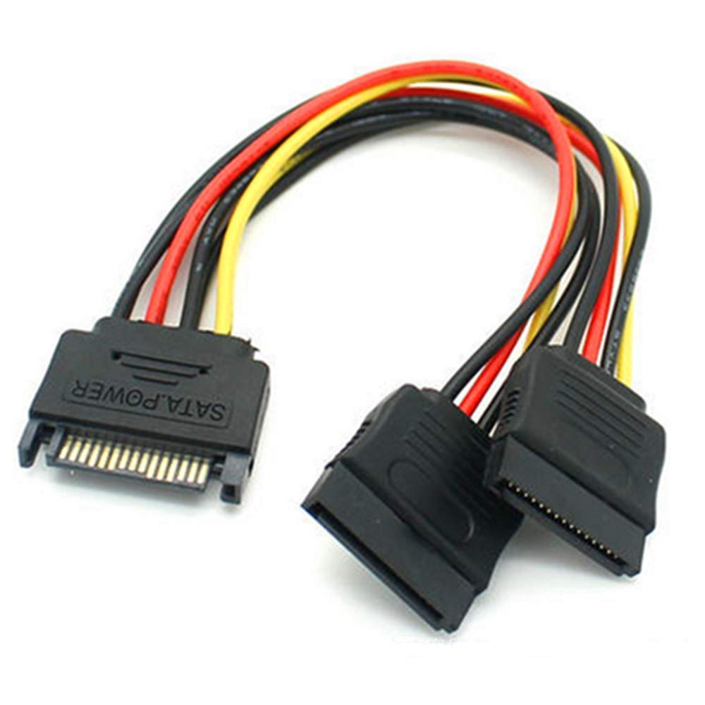

* PCI-E slots.

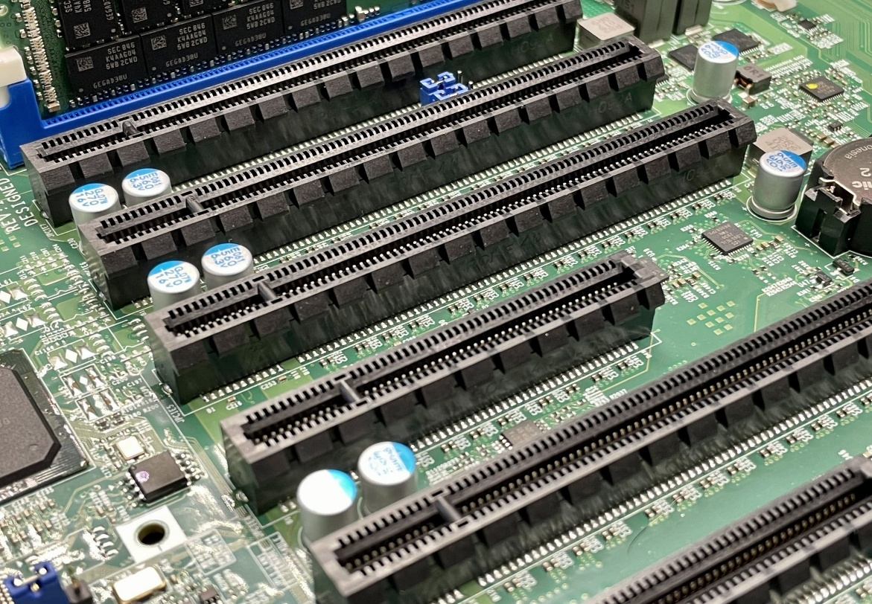

1. Demonstrate how to install a RAM module in computer.



* Shut down a computer and unplug it from the power outlet.
* Access the RAM slots by opening the computer case.
* Find the RAM slots on the motherboard.
* Open the clips on both sides of RAM slots.
* Gently push the RAM after the notch of the module lines up.
* After installing the RAM close the computer case and reconnect all cables.

Section 5 : Essay.

1. Discuss the importance of proper cooling mechanisms in a computer system. Include examples of cooling methods and their effectiveness.

* Proper cooling mechanism is essential in computer system , because computers generate significant amount of heat while operating.
* Too much heat can lead to low performance and hardware damage or shorten computer or laptop components lifespan and even lead to system failure.
* Importance of proper cooling mechanism.
* Maintain performance.
* Heat can cause thermal throttling , where CPU slows down automatically to prevent overheating.
* Prevent hardware damage.
* Overheating may damage sensitive part of the computer. And lead to failure.
* Increase lifespan of components
* A good cooling system can increase life span of component by preventing overheating.
* Example of cooling method.

1. Air cooling.
2. Liquid cooling.
3. Thermal paste.
4. Heat pipes and vapor changers.
5. Phase-change cooling.
6. Passive cooling.
7. Explain the concept of the bus width and its significance in computer architecture.

* A bus is a communication system that transfers data between different component of computer like CPU, memory and Input/Output devices.
* The bus width refers to the number of bits that can be transmitted simultaneously through the bus. It is usually measured in bits.

Types of buses and bus width:

* Data bus
* Determines how much data can you move between CPU , memory and peripheral at one time.
* A 64-bit data bus can move 8 bytes of data one clock time.
* Address bus
* Determines the maximum memory addresses the CPU can access.
* A 32-bit address bus can address up to **2³² = 4 GB** of memory.
* Control bus
* Transfers control signals
* Width affects how many unique control signals can be managed.

Significance of bus width

* Data transfer speed
* Wider bus = more data transferred per clock cycle.
* Memory addressing capcity
* The width of the address bus determines how much memory the system can directly use.
* System performance
* A wider bus reduces bottlenecks , especially in high performance systems.
* Compatibility with Software and Hardware
* Operating systems and applications must support the architecture